**Q.**

**Develop a calculator that should perform basic arithmetic operations, including addition, subtraction, multiplication, and division, while also handling errors gracefully. It should prompt users to input the operation and operands, and effectively manage common errors such as division by zero, invalid input types (e.g., letters instead of numbers), and unsupported operations. The program must provide clear error messages to guide users and allow them to try again without crashing. Your task is to design and implement this calculator in Python, ensuring it is robust and user-friendly.**

**solution:**

x= int(input("Enter the first value :"))

y= int(input("Enter the second value :"))

print("1. Addition of numbers")

print("2. Subtraction of numbers")

print("3. Multiplication of numbers")

print("4. Division of numbers")

switch = int (input("Enter your choice:"))

if switch == 1:

print(x+y)

elif switch == 2:

print(x-y)

elif switch == 3:

print(x*y)

elif switch == 4:

print(x/y)

if y == 0:

print("Division is not possible by zero")

else:

print(x/y)

else:

print("Invalid choice! Please enter correct choice")

Output:

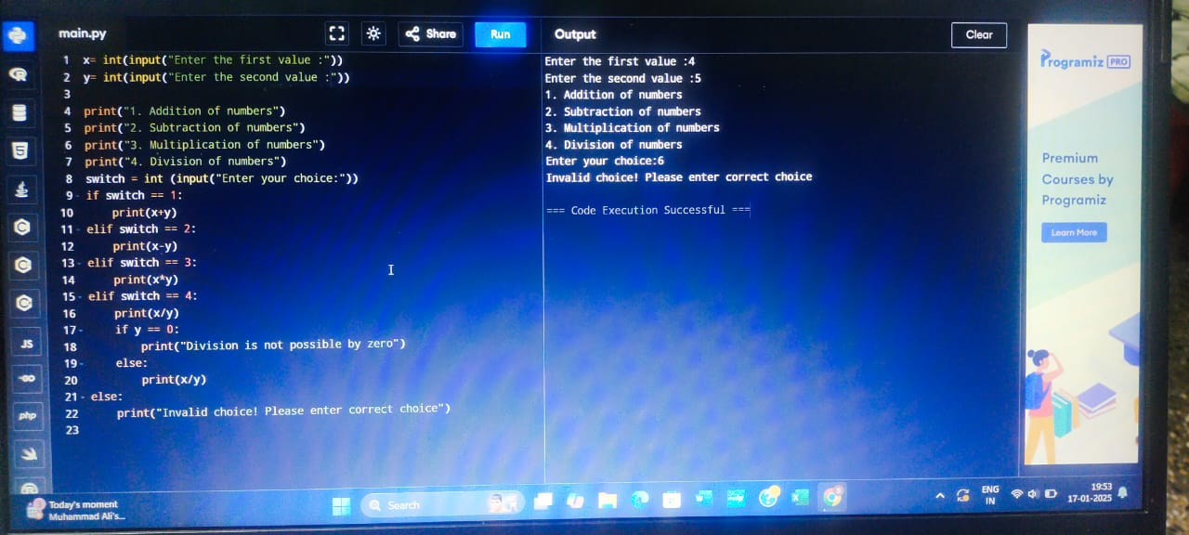

PRN: 2124UCSF1001

Department: CY